# **Title:** Obesity promotes glucocorticoid-dependent muscle atrophy in male C57BL/6J mice.

**Author names and affiliations:**

Laura C. Gunder1, Innocence Harvey1,2,3, JeAnna R. Redd1,2, Carol S. Davis3, Ayat AL-Tamimi1, Susan V. Brooks3 and Dave Bridges*,1,4,5

1. Department of Nutritional Sciences, University of Michigan School of Public Health, Ann Arbor, Michigan, USA.
2. Department of Physiology, University of Tennessee Health Science Center, Memphis, Tennessee, USA.
3. Adipocyte Biology Laboratory, Pennington Biomedical Research Center, Louisiana State University, Baton Rouge, Louisiana, USA.
4. Department of Molecular & Integrative Physiology, University of Michigan Medical School, Ann Arbor, Michigan, U.S.A.
5. Department of Pediatrics, University of Tennessee Health Science Center, Memphis, Tennessee, USA

* Corresponding author

**Corresponding author:**

Dave Bridges Email address: [davebrid@umich.edu](mailto:davebrid@umich.edu)

Postal address: 1836 SPH I, 1415 Washington Heights Ann Arbor, Michigan 48109-2029 Telephone: +1 (734) 764-1266

# Abstract

Glucocorticoids promote muscle atrophy by inducing a class of proteins called atrogenes, resulting in reductions in muscle size and strength. In this work, we evaluated whether a mouse model with pre-existing diet-induced obesity had altered glucocorticoid responsiveness. We observed that all animals treated with the synthetic glucocorticoid dexamethasone had reduced strength, but that obesity exacerbated this effect. These changes were concordant with more pronounced reductions in muscle size, particularly in Type II muscle fibers, and potentiated induction of atrogene expression in the obese mice relative to lean mice. Furthermore, we show that the reductions in lean mass do not fully account for the dexamethasone-induced insulin resistance observed in these mice. Together these data suggest that obesity potentiates glucocorticoid-induced muscle atrophy.

**Keywords**: Glucocorticoids, atrophy, obesity, atrogenes, insulin resistance

# Introduction

Skeletal muscle is vital to normal function and to the maintenance of health. Muscle is critical to the regulation of lipid, glucose and amino acid metabolism , processes which are commonly dysregulated in association with illness [1]. Many factors including age, poor nutrition, lack of exercise, medication, stress and diseases can lead to loss of skeletal muscle mass and function, with attendant reductions in lifespan and health span [2]. One causal factor in muscle loss is elevated glucocorticoids, either pharmacologically or as the result of chronic stress. It is estimated that 1-2% of individuals in the USA and UK are prescribed glucocorticoids [3,4]. Similarly chronically elevated glucocorticoids are associated with higher longitudinal risk of metabolic diseases [5,6]. While obesity affects approximately 40% of the American population [7], increasing the risk of type 2 diabetes, cardiovascular and liver disease among other comorbidities [8], the combination of glucocorticoids and obesity on outcomes of metabolic health has received little attention.

Elevated levels of glucocorticoids within the human body have been shown to cause skeletal muscle atrophy [11–14]. This muscle atrophy is due to increased muscle proteolysis and inhibition of protein synthesis [9,11], linked mechanistically to an upregulation of atrogenes (a class of E3 ubiquitin ligases) and a downregulation of mTORC1, as well as other factors [11,15–20]. Previous work by our group and others has demonstrated that glucocorticoids and obesity may have synergistically detrimental effects [9,10,21–23].

In this manuscript, we provide data that both lean and obese mice have reductions in lean mass, muscle mass, and strength when treated with dexamethasone and these effects are enhanced in obese mice. We show that obese, dexamethasone treated mice have elevated induction of key atrophy-inducing transcripts including *Fbxo32* and *Trim63*, (encoding Atrogin-1 and MuRF1 respectively) and their upstream regulator *Foxo3*. Lastly, we show the obese dexamethasone-treated mice are profoundly insulin resistant, even after accounting for reduced muscle mass.

# Results

In order to assess diet-induced obesity in mice, we randomized mice into diets of normal chow (NCD) or high fat diet (HFD), then after 12 weeks on their respective diets randomized again into treatment groups (dexamethasone or water). Prior to randomization into dexamethasone treatments, high fat diet animals had approximately the same percent body fat mass of 30%. Upon randomization, we evaluated food intake during the course of treatment to determine the possible origin of changes in adiposity. HFD-dexamethasone animals consumed approximately 70% more calories per day than water controls. Even though the HFD/dexamethasone mice ate the most calories, they lost both fat and lean mass and when compared to their HFD/water counterparts (Table 1) and consistent with our prior data [10]. This is suggestive of either increased energy expenditure or decreased digestive efficiency in these animals.

Our prior work demonstrated substantial elevations of dexamethasone ingestion over a five-week period in obese mice, an effect we proposed was secondary to their diabetic phenotype [10]. In this shorter exposure, while we noted a 36% reduction in fluid intake in both groups of dexamethasone-treated mice, there was no moderating effect of HFD treatment (p= 0.85 ; Table 1) indicating equivalent dexamethasone doses between NCD and HFD mice.

**Table 1: Body mass, fat mass, calorie and dexamethasone intake.** Asterisks indicate significant interaction between diet and dexamethasone treatment by two-way ANOVA. n=6-8 mice per group.

|  |  |  |  |  |
| --- | --- | --- | --- | --- |
|  | **NCD,**  **Water** | **NCD, Dexamethasone** | **HFD,**  **Water** | **HFD, Dexamethasone** |
| Body weight at sacrifice (g) | 31.5 ± 7.5 | 29.2 ± 1.5 | 46.5 ± 9.8 | 34.2 ± 1.6 * |
| Fat mass at sacrifice (g) | 3.1 ± 0.6 | 3.6 ± 0.5 | 16.0 ± 1.3 | 11.6 ± 1.6 * |
| Percent fat mass at sacrifice | 9.8 ± 1.7 | 12 ± 1.2 | 34 ± 2.0 | 33 ± 3.2 |
| Food intake per mouse per day during dexamethasone treatment (g) | 3.5 ± 0.09 | 3.7 ± 0.21 | 2.1 ± 1.0 | 3.6 ± .31 |
| Calorie intake per mouse per day during dexamethasone treatment (kcal) | 10.1 ± 0.26 | 10.8 ± 0.61 | 9.9 ± 4.7 | 17.0 ± 1.5 * |
| Fluid intake per mouse per day during dexamethasone treatment (mL) | 11.7 +/- 3.0 | 9.3 +/- 3.0 | 15.9 +/- 1.0 | 8.6 +/- 1.7 |

## Greater Losses in Grip Strength in Obese-Dexamethasone Mice

To assess the effect of glucocorticoids on overall muscle strength, we measured grip strength. Dexamethasone treatment resulted in reductions in grip strength in both lean and obese mice when compared to their non-treated counterparts (Figure 1A-B). Obese dexamethasone-treated mice had greater overall losses in grip strength when compared to the lean animals. We observed a 4.8% reduction in lean animals (p=0.007) but a 26.2% reduction in grip strength for obese animals (p=3.6x10-5).

## Reductions in Strength are Related to Smaller Cross-Sectional Area

In order to expand upon these results, we measured the force generated by gastrocnemius muscle *in situ*. These experiments were performed by stimulation of both the tibial nerve and by direct electrical stimulation of the muscle. In NCD animals, the force generated by nerve stimulation was reduced 10% when treated with dexamethasone. However, in HFD animals force generated by nerve stimulation was reduced 32% in animals treated with dexamethasone, with a significant interaction between pre-existing obesity and dexamethasone treatment (pinteraction=0.009, Figure 1C). Similarly, in NCD animals, force generated by direct muscle stimulation was reduced 11% when treated with dexamethasone, while in HFD animals, the force generated by direct muscle stimulation was reduced 30% when treated with dexamethasone relative to control animals (pinteraction=0.024, Figure 1D). These data suggest primarily a muscle-autonomous phenotype rather than the presence of functional denervation as the weakness was comparable with nerve and direct muscle stimulation. This also suggests that hyperglycemia-induced peripheral neuropathy is not a major explanation for these reductions.

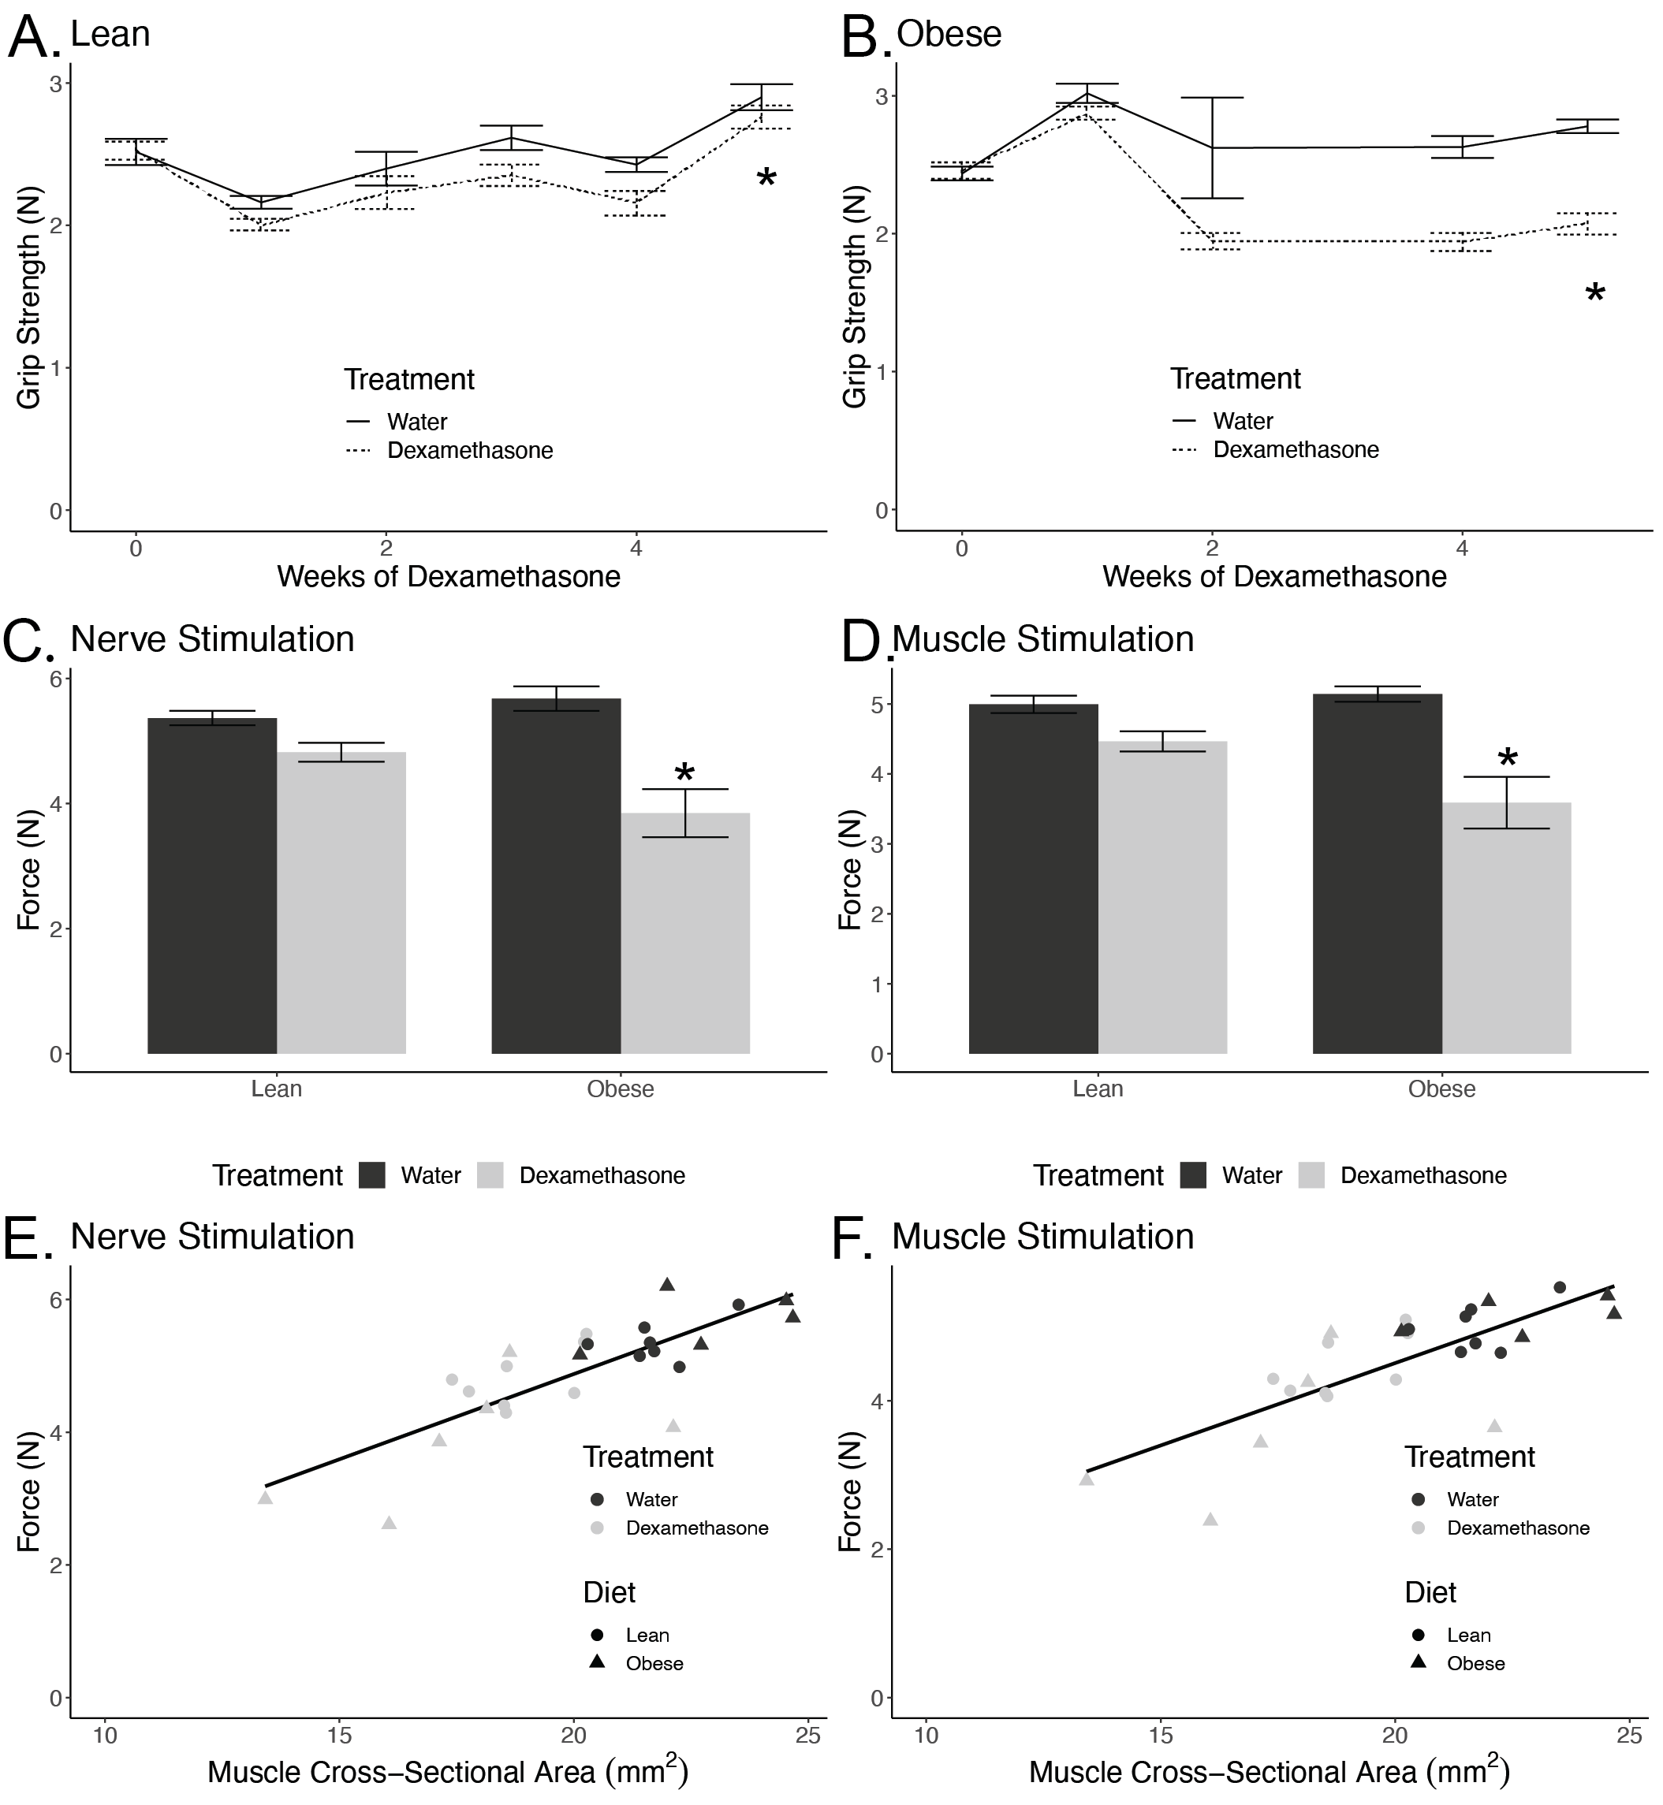

**Figure 1. Obese, Dexamethasone-Treated Mice Have Reduced Muscle Strength**

Grip strength in lean (A) and obese (B) male mice over several weeks of dexamethasone treatment (n=4-8 per group). Mice were fed a high fat diet (HFD) or normal chow diet (NCD) for twelve weeks prior to randomization into water or dexamethasone treatments. Force generated by nerve stimulation (C) and by direct muscle stimulation (D) of the gastrocnemius muscle in lean and obese mice treated with vehicle (water) or dexamethasone for 15-21 days after 12 weeks of NCD or HFD. Force plotted relative to whole muscle cross-sectional area (E-F). Asterisks indicate significant interaction between diet and treatment by two-way ANOVA (n=5-8 per group).

In order to examine whether changes in muscle strength were proportional to declines in muscle size, we plotted a regression of force versus whole-muscle cross-sectional area (CSA). The CSA explained 64% and 59% of the variance in force stimulated at the nerve and muscle respectively. As cross-sectional area declined, muscle force by both stimulations decreased in proportion. Regression modeling showed that pre-existing obesity did not significantly modify this force-CSA relationship (Nerve Stimulation: p=0.47, Muscle Stimulation: p=0.42). These data indicate that pre-existing obesity causes elevated dexamethasone-induced muscle weakness, but that this is largely explained by reductions in muscle size rather than qualitative defects in the force generating machinery within the muscle.

## Enhanced Muscle Atrophy in Obese Mice

The obese, dexamethasone-treated animals had larger reductions in fat free mass (Figure 2A), gastrocnemius weight and whole-muscle cross-sectional area (Figure 2B-C). At sacrifice, the NCD animals’ gastrocnemius weights were smaller after treatment with dexamethasone by 13% in the NCD treated group but by 27% in the HFD group (pinteraction=0.021). Similarly, cross-sectional area of the muscle was reduced 13% in the NCD group and 23% in the HFD group though the modifying effect of obesity did not quite reach statistical significance (pinteraction=0.11).

## Obesity with Dexamethasone Treatment Resulted in Smaller Type II Muscle Fibers

In order to assess changes at the individual muscle fiber-level, we cryosectioned the quadriceps from mice at the mid-belly and H&E stained these samples (Figure 2D). The lean animal’s muscle fibers were reduced by 17% in the dexamethasone treated groups, while obese animals muscle fibers were reduced by 55% in the dexamethasone treated mice (pinteraction=0.001; Figure 2E).

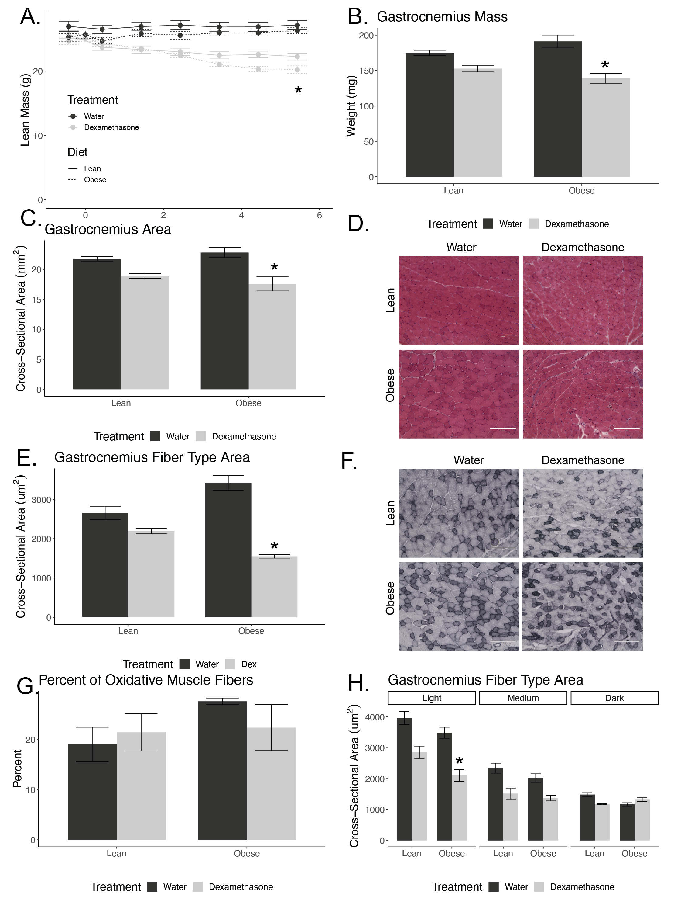

**Figure 2. Obese, Dexamethasone-Treated Mice Have Reduced Muscle Size.** A) Lean mass determined via EchoMRI. Gastrocnemius muscle mass (B) and cross-sectional area (E) from lean and obese mice treated with vehicle or dexamethasone (n=5-8 per group). H&E stained section of muscles (quadriceps; D) Average fiber cross-sectional area (E) averaged from 200 fibers per section (quadriceps; n=4 mice per group). NADH-NBT stained section of muscles (quadriceps; F) from mice treated with vehicle (water) or dexamethasone for six weeks. Percent of slow-oxidative or Type I fibers to total fibers (G; n=4 sections per group). Average fiber cross-sectional area separated by NADH-NBT staining density with dark fibers indicating slow-oxidative or Type I muscle fibers (quadriceps muscle; H). Asterisks indicate significant interaction between diet and dexamethasone treatment by two-way ANOVA.

In order to evaluate any changes in the ratio of oxidative versus non-oxidative fiber-types, we stained muscle sections and quantified the muscle fibers based upon their oxidative capacity. Mouse skeletal muscle is made up Type I, Type IIa, Type IIb, and Type IIx fibers [24,28]. Oxidative fibers or Type I fibers stain the darkest (Figure 2F). We found no significant change in the ratio of oxidative to total fibers in the mice quadriceps in lean or obese mice treated with dexamethasone (Figure 2G).

Using these cryosections, we next tested for fiber-type specific reductions in fiber size. Dexamethasone-treatment reduced Type IIa or light-stained fibers CSA in lean and obese mice by 28% and 40%, respectively, though the moderating effect of obesity did not reach statistical reference (pinteraction=0.49). Dexamethasone treatment also reduced Type IIb or medium-stained fibers CSA in lean and obese by 35% and 32%, respectively (pinteraction=0.58). As for Type I or dark-stained fibers, dexamethasone treatment only reduced fiber CSA in NCD animals. Dexamethasone treatment reduced Type I fiber CSA by 21% in lean, the treatment increased fiber CSA in obese mice by 14% (pinteraction=p=0.0031; Figure 2I).

## Obesity and Dexamethasone Cause Elevated Atrogene Expression

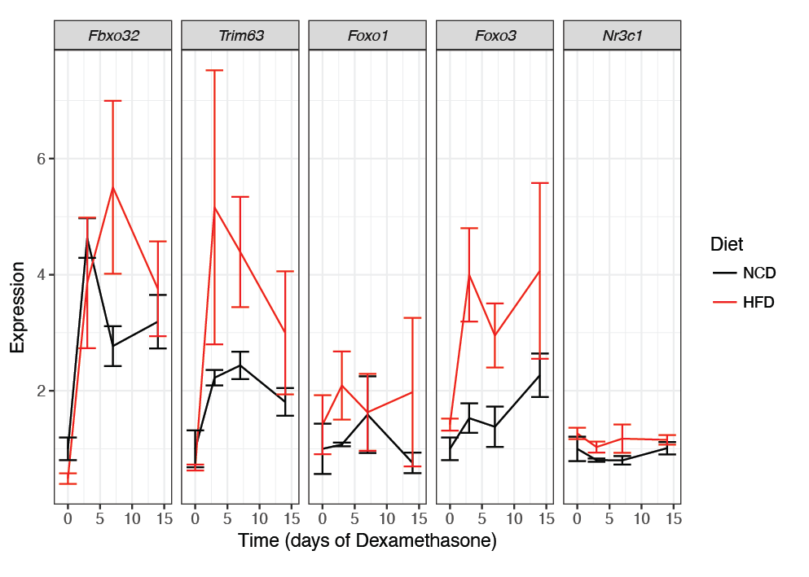

**Figure 3. Obesity Enhances Dexamethasone-Induced Muscle Degradation Transcripts.** Atrogene expression in NCD or HFD mice treated with vehicle or dexamethasone for the indicated time points and euthanized *ad libitum*.mRNA was extracted and quantified from quadriceps muscles. Asterisks indicate significant interaction between diet and dexamethasone treatment by two-way ANOVA. n=6-8 per group.

To evaluate the molecular effects of dexamethasone *in vivo* and how this was moderated by obesity, we determined atrogene expression in quadriceps after a two-week treatment time course, with animals euthanized at 0, 3, 7 and 14 days. After one week of dexamethasone treatment, we observed induction of *Foxo3* and the atrogenes, *Trim63* (Atrogin-1) and *Fbxo32* (MuRF1), to be greater in obese mice compared to their lean counterparts, though the interaction between obesity status and dexamethasone treatment did not reach statistical significance for these transcripts (Figure 3). We did not observe a treatment effect in either diet for *Foxo1* or *Ncr31* (the gene that encodes for the Glucocorticoid Receptor). These data suggest that the obesity-sensitizing effects on muscle atrophy could be related to transcriptional elevations of *Foxo3* and these two atrogenes.

### Obese Dexamethasone-Treated Mice are Insulin Resistant After Adjusting for Muscle Mass

We evaluated insulin sensitivity in these mice, as the majority of all postprandial glucose uptake occurs within the muscle [29]. In lean animals, there was no significant change in fasting blood glucose following dexamethasone treatment; however, there was a 44% increase in fasting blood glucose in obese animals given dexamethasone (pinteraction=0.033; Figure 4A), consistent with our previous report [10]. In order to evaluate whether the dexamethasone-treated animals were insulin resistant beyond what was expected by reductions in muscle mass, we adjusted insulin concentrations according to lean mass. In both lean and obese animals, dexamethasone induced near complete insulin resistance (p= 8.8 x 10-12 for NCD and 7.7 x 10-7 for HFD; Figure 4B). These data suggest that even after accounting for change in muscle mass, glucocorticoids still cause insulin resistance.

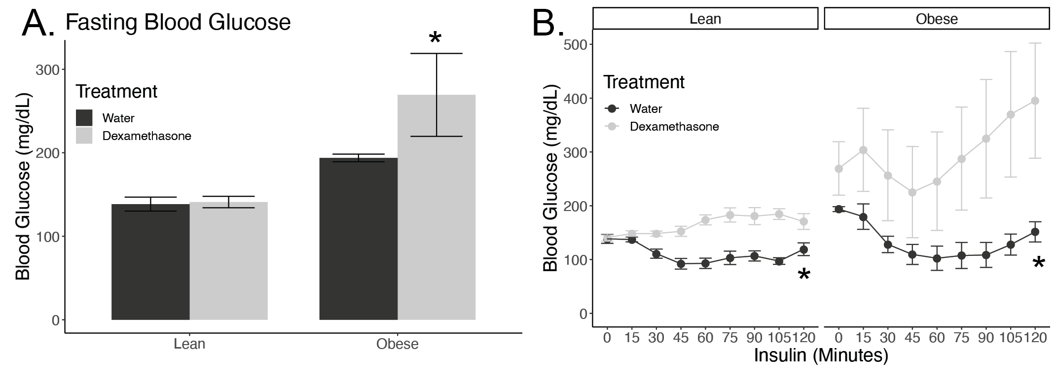

**Figure 4. Dexamethasone Treatment Induces Insulin Resistance.** Blood glucose values from lean and obese male mice after a 6-hour fast and two weeks of dexamethasone or vehicle (water) treatment (A), followed by insulin injection (B). n=4 mice per group. Insulin was given via intraperitoneal injection at 0.75g/kg lean mass for lean mice and 1.5g/kg for obese mice **(**n=4 mice per group).Asterisks indicate significant interaction between diet and treatment by two-way ANOVA (A) or mixed linear models (B) analyzed separately for lean and obese mice.

# Discussion

Here we demonstrate that dexamethasone treatment in concert with pre-existing obesity causes pronounced reductions in muscle strength, size and insulin sensitivity in mice. Muscle weakness is a common side effect of elevated exogenous and endogenous glucocorticoids [11,30]. For example, adults who had elevated salivary cortisol had a significantly higher risk of loss of grip strength than their peers [14]. This work could be particularly important because those with obesity are more likely to have reduced muscle function [31–34]. Notably, people with obesity are also more likely to have elevations in endogenous glucocorticoid levels [35,36]. Our model used exogenous glucocorticoid treatment in the form of dexamethasone, a fluorinated synthetic glucocorticoid with high selectivity for the glucocorticoid receptor over the mineralocorticoid receptor. Our dose of dexamethasone treatment is equivalent to a human dose of 80 g/kg/d, which is comparable to a high therapeutic dose administered to human patients, with a usual range from 2-200 g/kg/d [37–40] .

Glucocorticoids induce muscle atrophy in a muscle and fiber-type specific manner. Specifically, and consistent with our findings, Type II fibers are more prone glucocorticoid induced changes in cross-sectional area [11–13,30,41]. It is plausible that a selective loss in non-oxidative fiber functionality could reduce a human’s ability to use short bursts of energy, make rapid postural changes or lift heavy objects [42]. To our knowledge, the mechanisms causing differential specificity to glucocorticoids between fibers are not clear.

More broadly, the mechanisms underlying how increased responsiveness to dexamethasone in obese animals occurs are also not currently understood. Our data are also concordant with a report showing that glucocorticoids given simultaneously with HFD enhances muscle decay and exacerbated induction of atrogenes [23]. We did not observe transcriptional increases in GR in muscle (Figure 3) or adipose tissue [10] in obese animals that would explain these findings. One hypothesis is that obesity remodels the chromatin landscape, allowing for easier GR access to genes involved in modulating muscle size and function. Indeed, obesity alters the packing and accessibility of DNA in adipocytes [9,10,43] and therefore may have a similar effect in muscle in which Glucocorticoid Response Elements are more easily bound by GR causing increased glucocorticoid action. Another potential mechanism is that the effects of GR-dependent signaling are enhanced by insulin resistance by FOXO dephosphorylation, though in our case we observe substantial transcriptional activation of FOXO3.

Glucocorticoids and obesity both have deleterious health effects. These effects include loss of skeletal muscle which may result in reduced motor function, coordination, and energy production [31,33,34]. Insulin resistance is an additional negative effect associated with both elevated glucocorticoids and excess adiposity in the body [10,15,44]. The process by which these factors induce insulin resistance is not yet fully understood. In this study, we highlight that dexamethasone-induced muscle atrophy is exacerbated in an obese mouse model, as evidenced by synergistic reductions in muscle function, muscle mass, and fiber-specific cross-sectional area. Based on this, and prior findings that show dexamethasone treatment in the context of obesity exacerbates insulin resistance and NAFLD, whether humans with obesity are more prone to stress or drug-induced glucocorticoid responses should be considered when prescribing steroids.

# Materials and Methods

## Animal Husbandry

Male C57BL/6J mice were purchased from The Jackson Laboratory at nine weeks of age and randomized into groups of 3-4 animals/cage. All animals were on a light/dark cycle of 12 hours and housed at 22°C. At 10 weeks of age, mice were placed on a high-fat diet (HFD; 45% fat from lard, 35% carbohydrate mix of starch, maltodextrin, and sucrose, and 20% protein from casein, Research Diets cat no. D12451) or kept on a normal chow diet (NCD; 13% fat, 57% carbohydrate, and 30% protein; Teklad catalog no. 5LOD) for 12 weeks. At 22 weeks, mice were either treated with vehicle (water) or approximately 1 mg/kg/d of dexamethasone (Sigma-Aldrich; catalog no. 2915) dissolved in their drinking water. All mice were provided with *ad libitum* access to food and their respective waters throughout the study. Food and liquid consumption were measured weekly to determine the concentration of dexamethasone consumed per cage and volumes were averaged per mouse per cage. All animal procedures were approved by the University of Michigan or University of Tennessee Health Sciences Center Institutional Animal Use and Care Committees.

## Grip Strength

Mice were tested using a grip strength meter with a Chatillon digital force gauge (AMETEK). Mice were placed on a grid attached to the meter and once all four paws had contact with the grid, the mice were slowly pulled backwards by the tail until they left the grid. Each mouse was tested five times and given approximately 10 seconds rest between each test. Final measurements for grip strength were assessed by taking the average of the five trials and reported as average peak force (N).

## *In situ* Contractile Measurements

After isoflurane-induced anesthesia, the right gastrocnemius muscle was carefully isolated and a 4–0 silk suture was tied around the distal tendon. After the tendon was secured, it was cut so the hindlimb could be secured at the knee to a fixed post. Animals were placed on a temperature-controlled platform with continual drip of saline over the muscle at 37°C to keep it warm and hydrated. The distal tendon of the gastrocnemius muscle was tied to the lever arm of a servomotor (6650LR, Cambridge Technology). In order to measure force generated under circumstances when neuromuscular transmission of action potentials to activate the muscle fibers, a bipolar platinum wire electrode was used to stimulate the tibial nerve. The voltage of the electrode pulses was incrementally adjusted to find maximum isometric twitch and the muscle length was altered to find the optimal length (Lo). Optimal length is the length of the muscle in which the maximal twitch force was obtained. Once Lo was found, gastrocnemius muscles were kept at that length (Lo) and the frequency of 300 ms trains of pulses was increased in increments of 50 Hz until maximum isometric tetanic force (Po) was achieved. Muscles were rested for 1 minute in between stimulations. In order to measure force generated in response to direct depolarization of the muscle fibers bypassing the requirement for neuromuscular transmission of the activating stimulus, an electrode cuff was placed around the mid-belly of gastrocnemius for muscle stimulation. The same process was then repeated as described above for nerve stimulated contractions. After all force measurements, mice were sacrificed and both gastrocnemius and quadricep muscles were dissected, weighed, and snap frozen in liquid nitrogen and stored at -80°C.

## Histology and Fiber Type Quantifications

Quadriceps were collected and frozen in 2-methyl-butane cooled under liquid nitrogen. Quadricep samples were sectioned using a CryoStar NX350 HOVP Cryostat (Thermo Scientific) at -20°C with a thickness of 10um through the mid-belly and mounted on SuperFrost glass slides (Electron Microscopy Sciences, catalog no. 71882-01). For analysis of fiber cross-sectional area (CSA), fibers were assessed by hematoxylin and eosin (H&E staining) and for fiber-type, muscles were stained using NADH-NBT staining as described in [24,25]. Light-stained fibers were labeled as Type IIB fibers, medium-stained fibers as Type IIA and dark-stained as Type I fibers. The images were taken using a 20x objective of an EVOS XL digital inverted microscope (Life Technologies). Muscle fibers were individually counted in each image by a blinded investigator and the cross-sectional area was measured by outlining 150 randomly chosen fibers per image and using ImageJ [26].

## mRNA Quantification

Cells and tissues were lysed in TRIzol using a TissueLyser II (Qiagen) and RNA was extracted using a PureLink RNA kit (catalog no. 12183025; Life Technologies) following manufacturer’s instructions. Complementary DNA (cDNA) was synthesized using the High Capacity cDNA Reverse Transcription Kit without RNAse inhibitor (catalog no. 4368813; Life Technologies). Quantitative Real-Time Polymerase Chain reaction (qPCR) was performed using a QuantStudio 5 (Thermo Fisher Scientific) with primers, complementary DNA, and Power SYBR Green PCR Master Mix (catalog no. 4368708; Life Technologies) per manufacturer’s instructions. Messenger RNA (mRNA) expression levels were normalized to a control gene, *Pgk1* after evaluating eight control gene candidates (Primer sequences in Table 2).

Assessment of Insulin Tolerance

Insulin tolerance testing took place between ZT8 and ZT10 following a 6-hour fast. Mice were assessed for glucose levels using a handheld glucometer (Accuchek) with blood drawn from the tail vein. Insulin (Humulin R, Lilly) was then administered via intraperitoneal injection at 0.75 IU per kg of lean mass for lean mice (determined by echo MRI) and 1.5 IU per kg of lean mass for obese mice. Different insulin doses were used to obtain similar glucose responses in control mice. Glucose was measured in 15 minutes intervals for a total of two hours following insulin administration.

**Table 2: Primers used in this manuscript.** Key atrophy transcripts, *Fbxo32* and *Trim63*, (encoding Atrogin-1 and MuRF1, respectively) and their upstream regulators, *Foxo1* and *Foxo3. Pgk1* was used a control gene.

|  |  |  |
| --- | --- | --- |
| **Gene** | **Forward 5’-3’ Sequence** | **Reverse 5’-3’ Sequence** |
| *Fbxo32* | CTTCTCGACTGCCATCCTGG | GTTCTTTTGGGCGATGCCAC |
| *Trim63* | GAGGGCCATTGACTTTGGGA | TTTACCCTCTGTGGTCACGC |
| *Foxo1* | AGTGGATGGTGAAGAGCGTG | GAAGGGACAGATTGTGGCGA |
| *Foxo3* | AAACGGCTCACTTTGTCCCA | ATTCTGAACGCGCATGAAGC |
| *Pgk1* | CAAGCTACTGTGGCCTCTGG | CCCACAGCCTCGGCATATTT |

## Body, Fat, and Lean Mass Determination

Body weight was measured using a digital scale. Fat and lean mass were determined using an EchoMRI 2100 (EchoMRI), without sedation or anesthesia.

## Statistics

All results are represented as mean ± SEM. Two-Way ANOVA analyses, mixed linear models and Chi-squared tests were performed to test for significance and determine interactions between diet and dexamethasone treatment. Pairwise testing was performed after assessing normality and equal of variances. If Shapiro-Wilk test was insignificant, a Levene’s tests was performed, followed by Welch’s or Student’s *t*-test as noted in the figure legends. For non-normally distributed data, a Mann Whitney U-test was used. A p-value under 0.05 was considered significant. All statistical tests were conducted using R version 3.5.0 [27]. All raw data and analysis scripts are available at <http://bridgeslab.github.io/CushingAcromegalyStudy/>

# Acknowledgements

This work was supported by the Walter Block Scholarship and the Nutritional Sciences Dean’s Award (LG), R01-DK017535 (DB), a pilot and feasibility grant from the Michigan Diabetes Research Center (P30-DK020572 to DB) and the Functional Assessment Core of the Michigan Integrative Musculoskeletal Health Core Center (P30-AR069620).

# Author Contributions

Conceptualization, D.B, I.H, L.G and S.V.B..; Methodology, D.B., J.R.R and S.V.B. Validation, D.B., L.G and I.H., Formal Analysis, L.G., I.H. and D.B..; Investigation, L.G, I.H., C.S.D, A.A.T and J.R.R. Resources, D.B and S.V.B., Data Curation, D.B., I.H. and L.G..; Writing – Original Draft Preparation, L.G..; Writing – Review & Editing, L.G., D.B., I.H..; Visualization, L.G., I.H, D.B..; Supervision, D.B, and S.V.B..; Project Administration, D.B..; Funding Acquisition, D.B and S.V.B.

## Conflicts of Interest

No potential conflict of interest was reported by the authors.

# References

1. Wolfe, R.R. The underappreciated role of muscle in health and disease 1 Ϫ 3. **2018**, 475–482.

2. Lecker, S.H.; Jagoe, R.T.; Gilbert, A.; Gomes, M.; Baracos, V.E.; Bailey, J.; Price, S.R.; Mitch, W.E.; Goldberg, A.L. Multiple types of skeletal muscle atrophy involve a common program of changes in gene expression. *FASEB J.* **2004**, *18*, 39–51, doi:10.1096/fj.03-0610com.

3. Staa, T.P.V.A.N.; Leufkens, H.G.M.; Abenhaim, L.; Begaud, B.; Zhang, B.; Cooper, C.; van Staa, T.P.; Leufkens, H.G.M.; Abenhaim, L.; Begaud, B.; et al. Use of oral corticosteroids in the United Kingdom. *QJM* **2000**, *93*, 105–111, doi:10.1093/qjmed/93.2.105.

4. Overman, R.A.; Yeh, J.Y.; Deal, C.L. Prevalence of oral glucocorticoid usage in the United States: A general population perspective. *Arthritis Care Res.* **2013**, *65*, 294–298, doi:10.1002/acr.21796.

5. Reynolds, R.M.; Labad, J.; Strachan, M.W.J.; Braun, A.; Fowkes, F.G.R.; Lee, A.J.; Frier, B.M.; Seckl, J.R.; Walker, B.R.; Price, J.F. Elevated Fasting Plasma Cortisol Is Associated with Ischemic Heart Disease and Its Risk Factors in People with Type 2 Diabetes: The Edinburgh Type 2 Diabetes Study. *J. Clin. Endocrinol. Metab.* **2010**, *95*, 1602–1608, doi:10.1210/jc.2009-2112.

6. Hackett, R.A.; Kivimäki, M.; Kumari, M.; Steptoe, A. Diurnal Cortisol Patterns, Future Diabetes, and Impaired Glucose Metabolism in the Whitehall II Cohort Study. *J. Clin. Endocrinol. Metab.* **2016**, *101*, 619–625, doi:10.1210/jc.2015-2853.

7. Flegal, K.M.; Kruszon-Moran, D.; Carroll, M.D.; Fryar, C.D.; Ogden, C.L. Trends in Obesity Among Adults in the United States, 2005 to 2014. *JAMA* **2016**, *315*, 2284, doi:10.1001/jama.2016.6458.

8. Heymsfield, S.B.; Wadden, T.A. Mechanisms, Pathophysiology, and Management of Obesity. *N. Engl. J. Med.* **2017**, *376*, 254–266, doi:10.1056/NEJMra1514009.

9. Hochberg, I.; Harvey, I.; Tran, Q.T.; Stephenson, E.J.; Barkan, A.L.; Saltiel, A.R.; Chandler, W.F.; Bridges, D. Gene expression changes in subcutaneous adipose tissue due to Cushing’s disease. *J. Mol. Endocrinol.* **2015**, *55*, 81–94, doi:10.1530/JME-15-0119.

10. Harvey, I.; Stephenson, E.J.; Redd, J.R.; Tran, Q.T.; Hochberg, I.; Qi, N.; Bridges, D. Glucocorticoid-Induced Metabolic Disturbances Are Exacerbated in Obese Male Mice. *Endocrinology* **2018**, *159*, 2275–2287, doi:10.1210/en.2018-00147.

11. Schakman, O.; Kalista, S.; Barbé, C.; Loumaye, a; Thissen, J.P.P. Glucocorticoid-induced skeletal muscle atrophy. *Int. J. Biochem. Cell Biol.* **2013**, *45*, 2163–2172, doi:10.1016/j.biocel.2013.05.036.

12. Kelly, Frank J and Goldspink, D.F. The differing responses of four muscle types to dexamethasone treatment in the the Rat. *Biochem* **1982**, *175*, 147–151, doi:10.1093/nq/175.27.477f.

13. Bhasin, S.; Artaza, J.; Mahabadi, V.; Mallidis, C.; Ma, K.; Gonzalez-Cadavid, N.; Arias, J.; Salehian, B. Glucocorticoid-induced skeletal muscle atrophy is associated with upregulation of myostatin gene expression. *Am. J. Physiol. Metab.* **2015**, *285*, E363–E371, doi:10.1152/ajpendo.00487.2002.

14. Peeters, G.M.E.E.; Van Schoor, N.M.; Van Rossum, E.F.C.; Visser, M.; Lips, P. The relationship between cortisol, muscle mass and muscle strength in older persons and the role of genetic variations in the glucocorticoid receptor. *Clin. Endocrinol. (Oxf).* **2008**, *69*, 673–682, doi:10.1111/j.1365-2265.2008.03212.x.

15. Pereira, R.M.R.; Freire de Carvalho, J. Glucocorticoid-induced myopathy. *Jt. Bone Spine* **2011**, *78*, 41–44, doi:10.1016/j.jbspin.2010.02.025.

16. Sandri, M.; Sandri, C.; Gilbert, A.; Skurk, C.; Calabria, E.; Picard, A.; Walsh, K.; Schiaffino, S.; Lecker, S.H.; Goldberg, A.L. Foxo transcription factors induce the atrophy-related ubiquitin ligase atrogin-1 and cause skeletal muscle atrophy. *Cell* **2004**, *117*, 399–412, doi:10.1016/S0092-8674(04)00400-3.

17. Burke, S.J.; Batdorf, H.M.; Huang, T.-Y.; Jackson, J.W.; Jones, K.A.; Martin, T.M.; Rohli, K.E.; Karlstad, M.D.; Sparer, T.E.; Burk, D.H.; et al. One week of continuous corticosterone exposure impairs hepatic metabolic flexibility, promotes islet β-cell proliferation, and reduces physical activity in male C57BL/6 J mice. *J. Steroid Biochem. Mol. Biol.* **2019**, *195*, 105468, doi:10.1016/j.jsbmb.2019.105468.

18. Bentzinger, C.F.; Lin, S.; Romanino, K.; Castets, P.; Guridi, M.; Summermatter, S.; Handschin, C.; Tintignac, L.A.; Hall, M.N.; Rüegg, M.A. Differential response of skeletal muscles to mTORC1 signaling during atrophy and hypertrophy. *Skelet. Muscle* **2013**, *3*, 6, doi:10.1186/2044-5040-3-6.

19. Bentzinger, C.F.; Romanino, K.; Cloëtta, D.; Lin, S.; Mascarenhas, J.B.; Oliveri, F.; Xia, J.; Casanova, E.; Costa, C.F.; Brink, M.; et al. Skeletal muscle-specific ablation of raptor, but not of rictor, causes metabolic changes and results in muscle dystrophy. *Cell Metab.* **2008**, *8*, 411–24, doi:10.1016/j.cmet.2008.10.002.

20. Bodine, S.C.; Stitt, T.N.; Gonzalez, M.; Kline, W.O.; Stover, G.L.; Bauerlein, R.; Zlotchenko, E.; Scrimgeour, A.; Lawrence, J.C.; Glass, D.J.; et al. Akt/mTOR pathway is a crucial regulator of skeletal muscle hypertrophy and can prevent muscle atrophy in vivo. *Nat. Cell Biol.* **2001**, *3*, 1014–1019, doi:10.1038/ncb1101-1014.

21. Shpilberg, Y.; Beaudry, J.L.; D’Souza, A.; Campbell, J.E.; Peckett, A.; Riddell, M.C. A rodent model of rapid-onset diabetes induced by glucocorticoids and high-fat feeding. *Dis. Model. Mech.* **2012**, *5*, 671–680, doi:10.1242/dmm.008912.

22. Beaudry, J.L.; D’souza, A.M.; Teich, T.; Tsushima, R.; Riddell, M.C. Exogenous glucocorticoids and a high-fat diet cause severe hyperglycemia and hyperinsulinemia and limit islet glucose responsiveness in young male Sprague-Dawley rats. *Endocrinology* **2013**, *154*, 3197–3208, doi:10.1210/en.2012-2114.

23. Adhikary, S.; Kothari, P.; Choudhary, D.; Tripathi, A.K.; Trivedi, R. Glucocorticoid aggravates bone micro-architecture deterioration and skeletal muscle atrophy in mice fed on high-fat diet. *Steroids* **2019**, doi:10.1016/j.steroids.2019.05.008.

24. Sher, J.; Cardasis, C. Skeletal Muscle Fiber Types in the Adult Mouse. *Acta Neurol. Scand.* **1976**, *54*, 45–56, doi:10.1111/j.1600-0404.1976.tb07619.x.

25. Hebling, A.; Scabora, J.E.; Esquisatto, M.A.M. Muscle Fibre Types and Connective Tissue Morphometry in Frontal Muscle of Norfolk Rabbits (Oryctolagus cuniculus). *Int. J. Morphol.* **2009**, *27*, 187–191, doi:10.4067/s0717-95022009000100032.

26. Bergmeister, K.D.; Gröger, M.; Aman, M.; Willensdorfer, A.; Manzano-Szalai, K.; Salminger, S.; Aszmann, O.C. Automated muscle fiber type population analysis with ImageJ of whole rat muscles using rapid myosin heavy chain immunohistochemistry. *Muscle and Nerve* **2016**, *54*, 292–299, doi:10.1002/mus.25033.

27. R Core Team R: A Language and Environment for Statistical Computing 2019.

28. Schiaffino, S.; Reggiani, C. Fiber types in mammalian skeletal muscles. *Physiol. Rev.* **2011**, *91*, 1447–531, doi:10.1152/physrev.00031.2010.

29. DeFronzo, R.A. Lilly lecture 1987. The triumvirate: beta-cell, muscle, liver. A collusion responsible for NIDDM. *Diabetes* **1988**, *37*, 667–687, doi:10.2337/diab.37.6.667.

30. Falduto, M.T.; Czerwinski, S.M.; Hickson, R.C. Glucocorticoid-induced muscle atrophy prevention by exercise in fast-twitch fibers. *J. Appl. Physiol.* **2017**, *69*, 1058–1062, doi:10.1152/jappl.1990.69.3.1058.

31. Maffiuletti, N.A.; Jubeau, M.; Munzinger, U.; Bizzini, M.; Agosti, F.; De Col, A.; Lafortuna, C.L.; Sartorio, A. Differences in quadriceps muscle strength and fatigue between lean and obese subjects. *Eur. J. Appl. Physiol.* **2007**, *101*, 51–59, doi:10.1007/s00421-007-0471-2.

32. Abdelmoula, A.; Martin, V.; Bouchant, A.; Walrand, S.; Lavet, C.; Taillardat, M.; Maffiuletti, N.A.; Boisseau, N.; Duché, P.; Ratel, S. Knee extension strength in obese and nonobese male adolescents. *Appl. Physiol. Nutr. Metab.* **2012**, *37*, 269–75, doi:10.1139/h2012-010.

33. Hulens, M.; Vansant, G.; Lysens, R.; Claessens, A.L.; Muls, E. Exercise capacity in lean versus obese women. *Scand. J. Med. Sci. Sport.* **2001**, *11*, 305–309, doi:10.1034/j.1600-0838.2001.110509.x.

34. Zoico, E.; Di Francesco, V.; Guralnik, J.M.; Mazzali, G.; Bortolani, A.; Guariento, S.; Sergi, G.; Bosello, O.; Zamboni, M. Physical disability and muscular strength in relation to obesity and different body composition indexes in a sample of healthy elderly women. *Int. J. Obes.* **2004**, *28*, 234–241, doi:10.1038/sj.ijo.0802552.

35. Wester, V.L.; Staufenbiel, S.M.; Veldhorst, M. a B.; Visser, J. a; Manenschijn, L.; Koper, J.W.; Klessens-Godfroy, F.J.M.; van den Akker, E.L.T.; van Rossum, E.F.C. Long-term cortisol levels measured in scalp hair of obese patients. *Obesity* **2014**, *00*, 1–3, doi:10.1002/oby.20795.

36. Rosmond, R.; Chagnon, Y.C.C.; Chagnon, M.; Pe, L.; Chagnon, M.; Russe, L.P.E.; Carlsson, R.N.; Lindell, K.; Holm, G.; Chagnon, M.; et al. A glucocorticoid receptor gene marker is associated with abdominal obesity, leptin, and dysregulation of the hypothalamic-pituitary-adrenal axis. *Obes. Res.* **2000**, *8*, 211–8, doi:10.1038/oby.2000.24.

37. Levitan, R.D.; Vaccarino, F.J.; Brown, G.M.; Kennedy, S.H. Low-dose dexamethasone challenge in women with atypical major depression: Pilot study. *J. Psychiatry Neurosci.* **2002**, *27*, 47–51.

38. Lopes, M.W.; Leal, R.B.; Guarnieri, R.; Schwarzbold, M.L.; Hoeller, A.; Diaz, A.P.; Boos, G.L.; Lin, K.; Linhares, M.N.; Nunes, J.C.; et al. A single high dose of dexamethasone affects the phosphorylation state of glutamate AMPA receptors in the human limbic system. *Transl. Psychiatry* **2016**, *6*, doi:10.1038/tp.2016.251.

39. Nair, A.B.; Jacob, S. A simple practice guide for dose conversion between animals and human. *J. Basic Clin. Pharm.* **2016**, *7*, 27, doi:10.4103/0976-0105.177703.

40. Becker, D.E. Basic and Clinical Pharmacology of Glucocorticosteroids. *Anesth. Prog.* **2013**, *60*, 25–32, doi:10.2344/0003-3006-60.1.25.

41. Rouleau, G.; Karpati, G.; Carpenter, S.; Soza, M.; Prescott, S.; Holland, P. Glucocorticoid excess induces preferential depletion of myosin in denervated skeletal muscle fibers. *Muscle Nerve* **1987**, *10*, 428–438, doi:10.1002/mus.880100509.

42. Wilson, J.M.; Loenneke, J.P.; Jo, E.; Wilson, G.J.; Zourdos, M.C.; Kim, J.-S. The Effects of Endurance, Strength, and Power Training on Muscle Fiber Type Shifting. *J. Strength Cond. Res.* **2012**, *26*, 1724–1729, doi:10.1519/JSC.0b013e318234eb6f.

43. Kang, S.; Tsai, L.T.-Y.; Rosen, E.D. Nuclear Mechanisms of Insulin Resistance. *Trends Cell Biol.* **2016**, *26*, 341–351, doi:10.1016/j.tcb.2016.01.002.

44. Heller, E.A.; Cates, H.M.; Peña, C.J.; Herman, J.P.; Walsh, J.J. Mechanisms of Glucocorticoid-Induced Insulin Resistance: Focus on Adipose Tissue Function and Lipid Metabolism. **2015**, *17*, 1720–1727, doi:10.1038/nn.3871.Locus-Specific.